|  |  |  |  |
| --- | --- | --- | --- |
| **Name of Student: NINAD AVINASH PATIL** | | | |
| **Roll No: 33** | | **Lab Practical Number: 5(B)** | |
| **Title of Lab Practical: SQL Data Source**  **1. Use SqlDataSource to sort, filter and paging using Data Source objects.** | | | |
| **DOP: 21/04/2021** | | **DOS: 27/04/2021** | |
| **CO Mapped: CO1** | **PO Mapped: PO3, PO5, PO7,**  **PO12, PSO1, PSO2** | **Faculty Signature:** | **Marks:** |

**Practical No 5(B)**

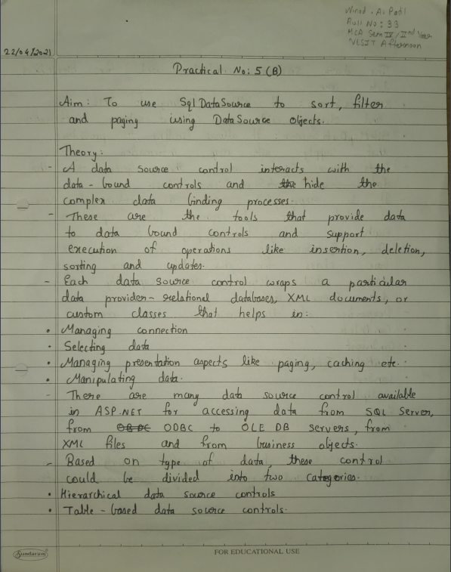

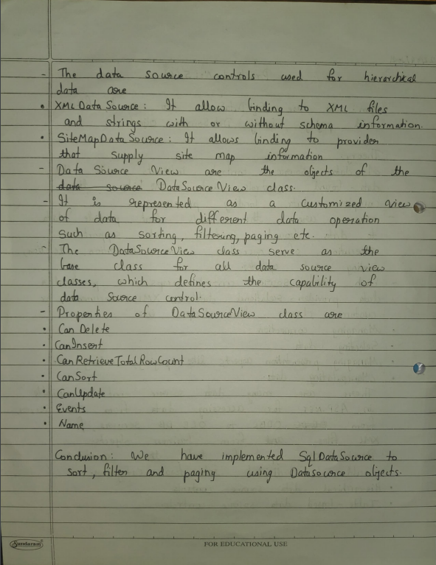

**Code:**

**WebForm1.aspx.cs**

using System;

using System.Collections.Generic;

using System.Linq;

using System.Web;

using System.Web.UI;

using System.Web.UI.WebControls;

namespace P5B {

public partial class WebForm1 : System.Web.UI.Page {

protected void Page_Load(object sender, EventArgs e)

{ }

protected void Button1_Click(object sender, EventArgs e) {

string FilterExpressions = string.Concat(DropDownList1.SelectedValue, " Like '%{0}%'");

SqlDataSource1.FilterParameters.Clear();

SqlDataSource1.FilterParameters.Add(new ControlParameter(DropDownList1.SelectedValue, "TextBox1", "Text"));

SqlDataSource1.FilterExpression = FilterExpressions;

} } }

**WebForm1.aspx**

<%@ Page Language="C#" AutoEventWireup="true" CodeBehind="WebForm1.aspx.cs" Inherits="P5B.WebForm1" %>

<!DOCTYPE html PUBLIC "-//W3C//DTD XHTML 1.0 Transitional//EN" "http://www.w3.org/TR/xhtml1/DTD/xhtml1-transitional.dtd">

<html xmlns="http://www.w3.org/1999/xhtml">

<head runat="server">

<title></title>

</head>

<body>

<form id="form1" runat="server">

<div>

SORTING, FILTERING &amp; PAGING<br />

<br />

</div>

<asp:GridView ID="GridView1" runat="server" AutoGenerateColumns="False" DataSourceID="SqlDataSource1" AllowPaging="True" AllowSorting="True" PageSize="5">

<Columns>

<asp:BoundField DataField="RollNo" HeaderText="RollNo" SortExpression="RollNo" />

<asp:BoundField DataField="Name" HeaderText="Name" SortExpression="Name" />

<asp:BoundField DataField="Course" HeaderText="Course" SortExpression="Course" />

</Columns>

</asp:GridView>

<asp:SqlDataSource ID="SqlDataSource1" runat="server" ConnectionString="<%$ ConnectionStrings:datasourceConnectionString %>" SelectCommand="SELECT * FROM [source]"></asp:SqlDataSource>

<br />

<asp:Label ID="Label1" runat="server" Text="Search by"></asp:Label>

&nbsp;&nbsp;&nbsp;

<asp:DropDownList ID="DropDownList1" runat="server" AppendDataBoundItems="True" AutoPostBack="True">

<asp:ListItem>RollNo</asp:ListItem>

<asp:ListItem>Name</asp:ListItem>

<asp:ListItem>Course</asp:ListItem>

</asp:DropDownList>

&nbsp;&nbsp;&nbsp;

<asp:TextBox ID="TextBox1" runat="server"></asp:TextBox>

&nbsp;&nbsp;&nbsp;

<asp:Button ID="Button1" runat="server" Text="Filter" onclick="Button1_Click" />

</form>

</body>

</html>

**Output:**

